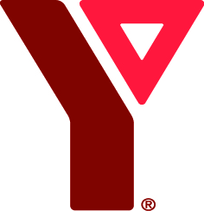

YMCA of Niagara
Making Waves Swimming and Leadership Bursary Application 2018

Name ________________________________________________________

Address ________________________________________________________

City/Postal Code _________________________________________________________

Phone Number __________________________________________________________

Birth Date __________________________________________________________

E-mail address __________________________________________________________

Parent/ Guardian Signature _________________________________________________________

Swimming Levels Achieved _________________________________________________________

Swimming Levels Applying to Achieve __________________________________________________

In resume format please provide us with:
- Leadership experience
- YMCA experience

In paragraph format (no longer than 1 page)
- Describe the aquatic program or opportunity you are planning to undertake and the reasons why you have chosen this.
- Describe your financial need.

Completed application forms and accompanying documentation can be can given to aquatic staff at your local branch or forwarded directly to.

Kristy McKitrick
Manager of Development
YMCA of Niagara, Walker Family YMCA
25 YMCA Drive
St. Catharines, ON L2N 7P9
kristy.mckitrick@niagara.ymca.ca
T: 905 934 9755 x231
F: 905-934 9665

